Solar Curtailment Project Documentation

# 13/09/2022

# Result on Tripping – non clear sky day (sample 1)

# Result on Tripping – clear sky day (sample 11)

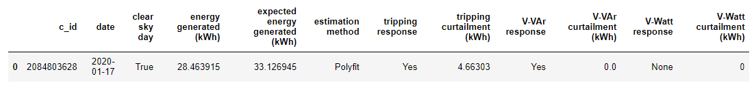

# Result on VVAr (sample 14)

## There are two issues:

1. In the reactive power scatter plot, the Q/VA should have been negative. Problem with polarity correction?
2. In the power and voltage plot, the power limit vvar is below the actual power value. Probably the actual VA limit of the inverter is higher than the ac capacity of the inverter?

# Result on VWatt (sample 4)

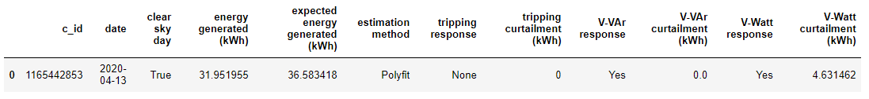

# Result on Incomplete Dataset (sample 5)



The tool will judge the dataset is incomplete only if there are less than 1000 rows in the data. The data should be more than that because the data resolution is either 60 or 5 seconds in SolA dataset.

# Polyfit with Constrain Idea Testing

When we implement the polyfit with constrain into a clear sky day without curtailment, it seems we get overestimating:

With constrain:

Without:

Should we give up on this? Or should we still think to optimize it since VWatt calculation is inaccurate and sometime it is underestimating, eg in sample 3:

Without constrain:

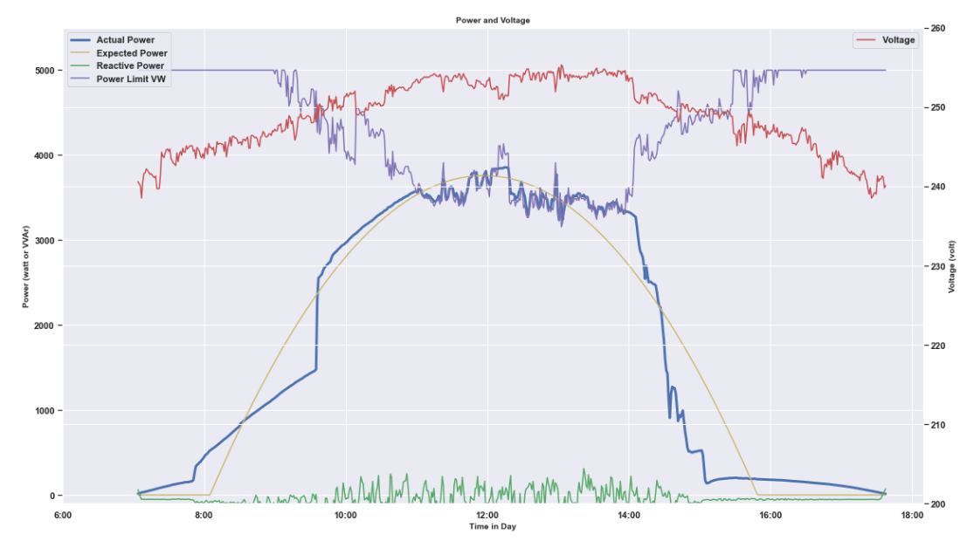

With constrain:

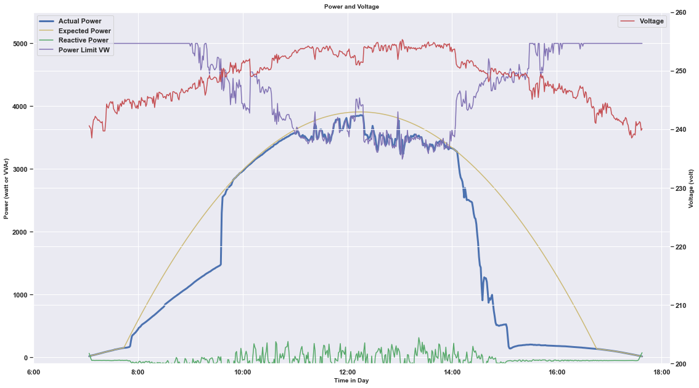

# Questions:

1. Polarity correction for VVAr?
2. VA capacity assumed to be bigger than AC capacity?
3. Just recheck, so if tripping happens in a day, it is not possible for vvar or vwatt happens?
4. How to calculate the VVAr curtailment and VWatt curtailment in a day with both response?
5. Is it true that sample 7 is a sample data which have VVAr and VWatt at the same time? (issue 18 in Github)